Stock Price Forecasting System for Adani Ports
Using Technical Indicators and Machine Learning
Models

Jhilik Biswas
MBATech AI
Mukesh Patel School of Technology Management And Engineering
India
jhilik.biswas25@nmims.in

Laksh Gupta
MBATech AI
Mukesh Patel School of Technology Management And Engineering
India
laksh.gupta28@nmims.in
Disha Gaonkar
MBATech AI
Mukesh Patel School of Technology Management And Engineering
India
disha.gaonkar11@nmims.in
Kanishka Gole
MBATech AI
Mukesh Patel School of Technology Management And Engineering
India
kanishka.gole05@nmims.in

Abstract—In the dynamic landscape of financial markets, accurate stock price forecasting is a complex yet essential task for informed investment decisions. This research introduces a comprehensive stock price forecasting system tailored for Adani Ports and Special Economic Zone Ltd., leveraging the predictive capabilities of machine learning (ML) models and the analytical power of technical indicators. Developed as a user-friendly Streamlit web application, the system integrates multiple supervised ML algorithms including Linear Regression, Random Forest, and Support Vector Machines to predict both Open and Close prices with high precision.
The system utilizes lag features, moving averages (MA), percentage change, and rolling standard deviation to construct a robust feature set. Users can interactively select models, visualize historical trends, and compare forecast accuracy through metrics like RMSE and R². A modular architecture enables dual-model forecasting with candlestick-style visualizations for short-term and extended future predictions. Additionally, real-time predictions can be exported for further analysis, enhancing the practical utility of the tool for retail investors and financial analysts.
The experimental results demonstrate the effectiveness of the integrated approach, highlighting the superiority of ensemble-based models for short-term trend prediction. The paper also discusses key considerations in feature engineering, model selection, and deployment, offering a reproducible methodology for stock forecasting in similar financial contexts.
Keywords—Time Series Forecasting, Regression Models, Data Visualization, Predictive Analytics, Streamlit, Lag Features

Introduction
Stock price prediction plays a pivotal role in financial analysis, portfolio management, and algorithmic trading. Accurate forecasting of stock movements can significantly enhance decision-making for investors, traders, and financial analysts. Traditional statistical methods often fall short in capturing complex patterns in financial time series, especially under volatile market conditions. In recent years, the advancement of machine learning (ML) algorithms and the availability of high-frequency financial data have opened new avenues for predictive modeling in the stock market.
With the rise of accessible artificial intelligence frameworks and financial APIs, real-time stock forecasting has become achievable through lightweight, interactive web applications. This convergence of ML and web technologies allows the creation of decision-support systems that are not only accurate but also user-friendly and accessible to a broader audience.
This research focuses on developing a Streamlit-powered dashboard for forecasting the stock prices of Adani Ports and Special Economic Zone Ltd., one of India’s leading port infrastructure companies. The system integrates various technical indicators and regression-based ML models to provide robust predictions of both Open and Close prices. Through a combination of lag features, feature engineering, and model comparison tools, the application enables real-time forecasting, trend visualization, and export functionalities for further financial analysis.
The proposed approach aims to bridge the gap between technical stock forecasting models and their practical usability by deploying the solution as an interactive web-based platform. The system not only supports informed investment decisions but also demonstrates a replicable methodology for similar forecasting problems in financial domains.

Literature Review
Stock price forecasting remains a critical area of exploration within finance and data science. While deep learning and classical statistical models have often dominated past research, this study emphasizes practical, interpretable machine learning approaches for stock prediction.
Recent studies highlight the effectiveness of traditional machine learning models—such as Decision Trees, Support Vector Machines (SVM), and ensemble methods like Random Forests and Gradient Boosting—for financial forecasting. These models, when combined with domain-specific features such as lag variables and technical indicators, can deliver robust predictions while maintaining interpretability. This balance between predictive power and transparency is vital in financial contexts where model outputs influence high-stakes decisions.
Moreover, there is growing attention toward explainable AI (XAI) in the financial sector. Explainable models not only generate accurate forecasts but also reveal the underlying factors driving stock movements, thereby fostering trust among analysts, investors, and regulatory bodies.
Our approach builds on this need for transparency by utilizing machine learning models like Random Forest, Gradient Boosting, and LightGBM, optimized with hyperparameter tuning and enriched with engineered features. This ensures that our models are not just accurate but also interpretable and adaptable to varying market conditions.
Additionally, this study integrates interactive visualizations and real-time parameter tuning through a Streamlit-based dashboard. This design empowers users to experiment with different models, evaluate performance metrics, and visualize results dynamically, making the tool both educational and practically valuable. By avoiding black-box deep learning methods and focusing on transparent, ML-driven strategies, our work offers a reliable and user-friendly solution for stock price forecasting.

System Overview

The system leverages various technologies to provide a comprehensive solution for predicting AdaniPorts stock prices. It integrates data science tools with a user-friendly frontend to facilitate both model training and forecasting. Below is an outline of the key components:
1. Frontend: Streamlit
- User Interface: The frontend is powered by Streamlit, a Python framework for building web apps for data science projects. It provides interactive components like sliders, buttons, and drop-down menus to control model parameters, forecast ranges, and visualize the results.
- Visualizations: Streamlit is used to display various plots (e.g., line plots, candlestick charts) generated by Plotly and Matplotlib. It allows for dynamic visualizations of the stock price prediction and time-series analysis.
2. Backend: Python (Pandas, Scikit-learn, Plotly)
- Data Handling: The backend is implemented in Python using libraries such as Pandas for data manipulation and Scikit-learn for machine learning model development. Pandas handles data preprocessing, including date parsing and managing missing values.
- Plotly: This library is used for generating interactive visualizations like candlestick charts for stock price predictions. It enhances the user experience by enabling zooming and hovering functionalities on the charts.
- ML Algorithms: Several machine learning models are used for predicting future stock prices, including:
  - Linear Regression: A simple yet powerful method for predicting continuous values like stock prices.
  - Random Forest: A robust ensemble method known for its accuracy and ability to handle overfitting.
  - Support Vector Machine (SVM): A powerful classifier often used for regression tasks.
  - K-Nearest Neighbors (KNN): A non-parametric method that works well in various prediction scenarios.
  - XGBoost: A gradient boosting algorithm that is known for its performance in time series forecasting tasks.
3. Data Source: Yahoo Finance API via yfinance
- The system fetches historical stock price data (Open, Close, High, Low, Volume) for AdaniPorts from Yahoo Finance using the yfinance library. This data is used for training and testing machine learning models as well as generating features for prediction.
- 4. Core Modules:
- Data Preprocessing:
  - Handling missing values (NA) and date parsing to ensure the dataset is clean and usable for training.
- Feature Engineering:
  - Technical indicators like Moving Averages (MA), Relative Strength Index (RSI), Bollinger Bands, etc., are calculated as additional features to improve prediction accuracy.
  - Lag features are also created, which are crucial for supervised learning in time series forecasting, capturing past price trends to predict future stock movements.
- Machine Learning Model Training:
  - The system trains multiple models (Linear Regression, Random Forest, SVM, KNN, XGBoost) using the historical stock data.
  - Models are evaluated using metrics like Mean Absolute Error (MAE), Root Mean Squared Error (RMSE), and R² to assess performance.
- Time Series Visualization:
  - Line plots and candlestick charts are used to visualize historical stock prices and predictions. These visualizations help users understand the trends and predict the future movement of stock prices.
5. Forecasting Future Close and Open Prices
- The system is capable of forecasting both Close and Open prices for the next day (or a selected time horizon). It achieves this by using lagged features to train the models, allowing them to recognize patterns from historical data and make accurate predictions.
This system provides an intuitive interface for users to experiment with various machine learning models and features, with the ability to visualize predictions and model evaluation metrics directly on the frontend.

Methodology
A. Dataset
The dataset for predicting the stock prices of AdaniPorts was obtained using the Yahoo Finance API (yfinance.download("ADANIPORTS.NS", ...)) with a daily frequency. The dataset includes the following features:
- Open: The opening price of the stock for the day.
- High: The highest price reached during the day.
- Low: The lowest price reached during the day.
- Close: The closing price of the stock for the day.
- Volume: The total number of shares traded on that day.
- Adjusted Close: The closing price adjusted for dividends, stock splits, etc.

Data from the years 2020 and 2021 was excluded to avoid the impact of the COVID-19 pandemic on market behavior, ensuring the model is trained on more stable data.

B. Feature Engineering
The following features were engineered to capture various patterns in the stock data and to improve the model's forecasting capabilities:
- Lag Features:
  - Close(t-1), Close(t-2), etc., which capture the previous closing prices for time-series modelling.
- Technical Indicators:
  - Moving Averages (MA7, MA21): These moving averages help smooth out price data and identify trends.
  - Standard Deviation (STD7): A measure of the volatility of the stock price.
  - Daily % Change: Calculated as ((Close - Open) / Open) * 100, capturing the daily percentage change in stock price.
  - Relative Strength Index (RSI): This was considered for inclusion to measure the speed and change of price movements but was not implemented in the provided code

C. Machine Learning Models
The following machine learning models were implemented to forecast the Close and Open prices of the stock:
- Linear Regression (LR): A simple regression model used as a baseline for comparisons.
- Random Forest Regressor (RF): An ensemble method based on decision trees, suitable for capturing non-linear patterns.
- Support Vector Regression (SVR): A regression model based on support vector machines, effective for handling high-dimensional data.
- K-Nearest Neighbors (KNN): A non-parametric model that makes predictions based on the average of the closest neighbors.
- XGBoost Regressor: A gradient boosting model that provides high predictive accuracy and is robust to overfitting.
Each model was trained and evaluated independently for predicting both the Close and Open prices, ensuring that the best-performing models were selected for each prediction task.

D. Forecasting Approach
The forecasting approach follows an iterative method where the most recent known lag features are used to predict future values. The predictions for future days are recursively fed back into the model to forecast subsequent days. Specifically:
- Training the Model: Each model is trained using a set of engineered features (Open, Volume, Daily Change, Change %, Moving Averages, Standard Deviation).
- Prediction: Once the model is trained, it is used to predict the stock price for the next time step (i.e., the next day).
- Iterative Forecasting: The forecasted value for a given day is used as an input for predicting the next day's price. This process continues for a user-defined number of future days, enabling predictions for multiple days into the future.
- E. Model Evaluation
The models were evaluated using the following metrics:
- R² Score: This indicates how well the model fits the data. A higher R² indicates better fit.
- Mean Absolute Error (MAE): This metric calculates the average absolute difference between the predicted and actual values.
- Root Mean Squared Error (RMSE): A more sensitive error metric that penalizes large prediction errors more heavily than MAE.

F. Model Selection and Hyperparameter Tuning
To improve the performance of the models, hyperparameters for tree-based models (Decision Tree, Random Forest, etc.) were tuned using user-adjustable sliders in the Streamlit app. Key hyperparameters such as the number of estimators, maximum depth, and minimum samples for splitting nodes were adjusted to optimize each model's performance.
For models that require scaling (such as SVR and KNN), a StandardScaler was applied to normalize the feature data before fitting the model.

G. Time Series Forecasting and Visualization
The Streamlit app provides a time series plot of the stock's historical closing prices and allows users to interactively select a model and forecast future stock prices. Users can visualize the forecasted values and evaluate the models based on the R², MAE, and RMSE metrics.
Moreover, the app provides an interactive tab for model comparison, where users can assess different models based on their performance metrics, allowing for a comprehensive understanding of which model performs best under various conditions.

User Interface
The frontend of the stock prediction system is designed using Streamlit to provide an intuitive and user-friendly interface. The interface includes the following key features:
- Sidebar for Model Selection: Users can select different machine learning models for stock prediction, including Linear Regression, Random Forest, and others. This provides flexibility in exploring various model outcomes.
- Dataset Visualization: The system visualizes the historical stock data through line charts and candlestick charts. The line chart allows users to see the general trend of stock prices over time, while the candlestick chart offers a more granular view of price movements, providing detailed information about Open, High, Low, and Close prices.
- Model Performance Comparison: The UI includes an output section that compares the performance of different models. This section displays key evaluation metrics such as accuracy, mean squared error, and R-squared value, enabling users to easily compare the effectiveness of the chosen models.
- Forecast Tab for Future Price Prediction: This section allows users to select the forecast period for stock predictions, such as next-day Close or Open prices. The predicted results are displayed in both numerical and graphical formats, providing clear insights into future price movements.
- Download Option for Results: After performing predictions, users can download the results in a CSV file, making it easy to export the data for further analysis or record-keeping.

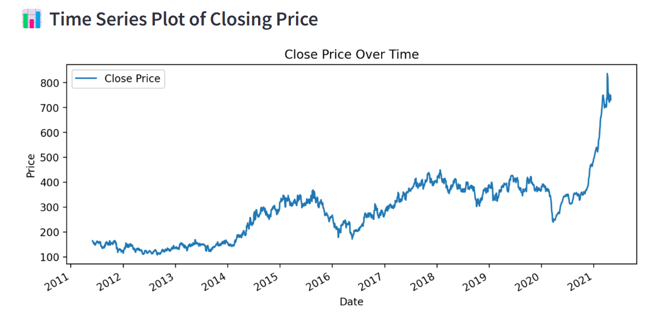

Fig.1 Homepage UI with Time Series Chart

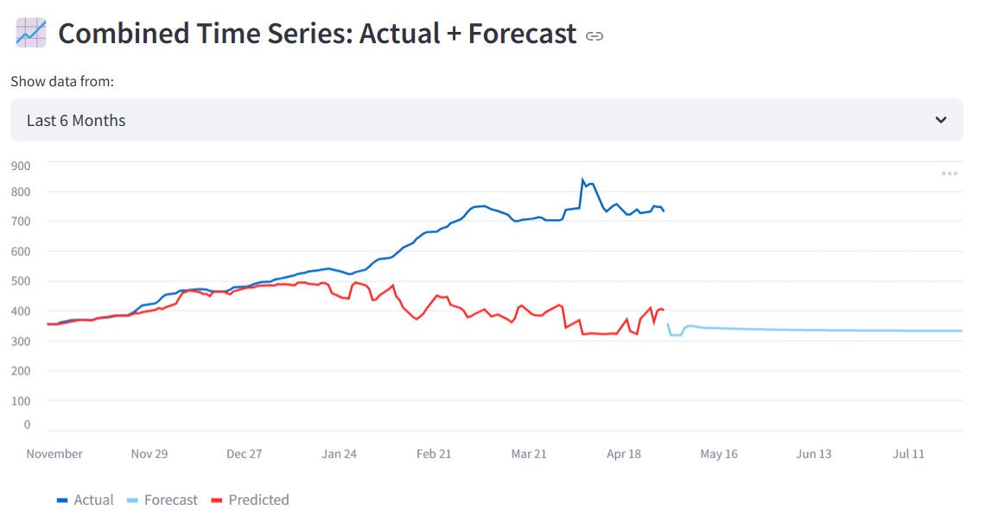

Fig.2 Support Vector regressor model: Predicted Close Prices

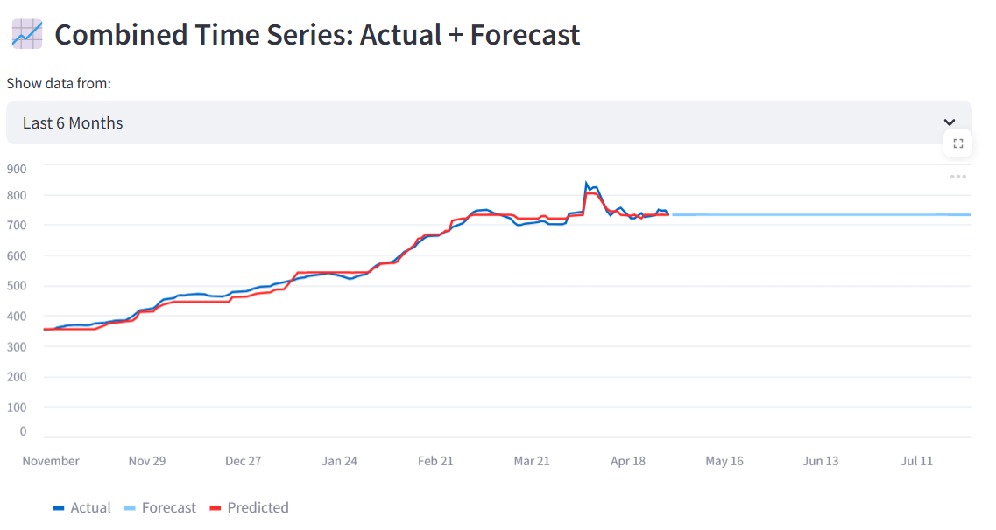

Fig.3 AdaBoost Regressor: Predicted Close Prices

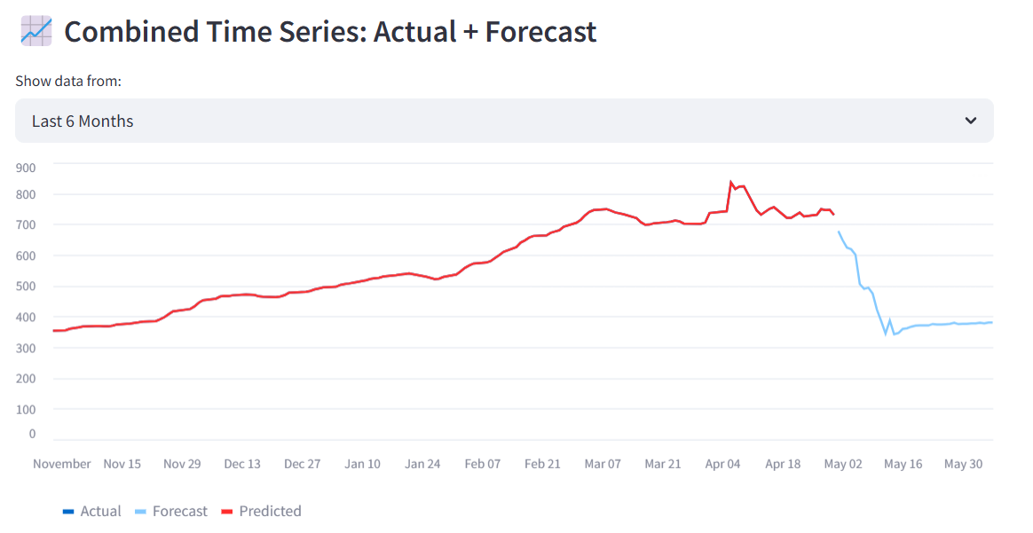

Fig.4 KNN Regressor: Predicted Close Prices

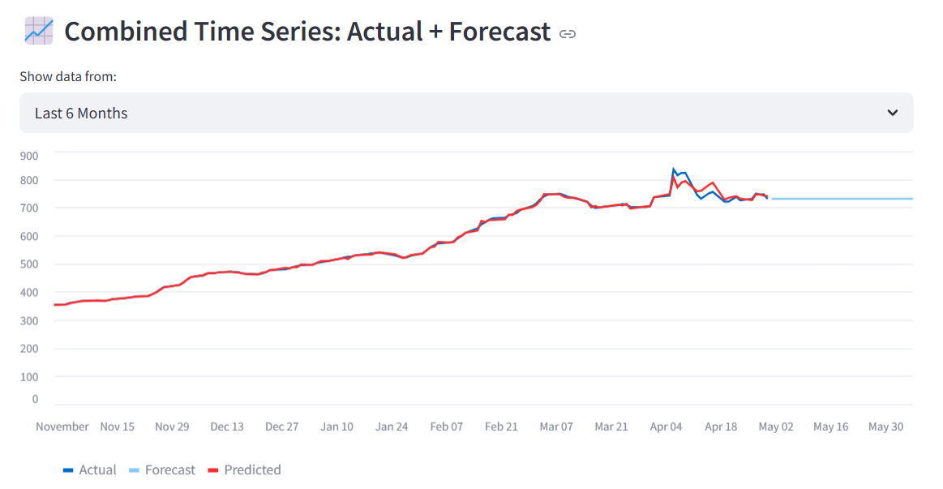

Fig.5 LightGBM Regressor: Predicted Close Prices

FUTURE STOCK PRICES BY DATE:
The Streamlit application incorporates an intuitive feature that allows users to input a specific date for which they wish to predict stock prices. This functionality enhances the interactivity of the system by enabling personalized forecasting. Users simply select a date from the provided input field, and the system processes the request by leveraging the pre-trained machine learning models, which have been trained on historical stock data.
Once the desired date is selected, the application uses the selected date as an input to forecast both the opening and closing prices for that particular day. The machine learning models—such as Support Vector Regressor (SVR), Random Forest, or XGBoost—are applied to generate predictions based on the historical patterns and trends within the data. The predicted stock prices for both the opening and closing values are then displayed prominently on the interface.
This feature provides a valuable tool for users to assess future stock performance for specific dates, making it easier to compare the model’s predictions with the actual market data as it becomes available. By allowing users to input any date in the future, this feature helps traders and analysts plan and make informed decisions based on data-driven predictions.
Moreover, the inclusion of this personalized prediction feature fosters a more engaging user experience, where users can experiment with different forecast scenarios, analyze trends, and test how well the model performs in real-time. This flexibility makes the application suitable not only for individual stock traders but also for financial analysts and investors who need accurate price forecasts for specific timeframes.

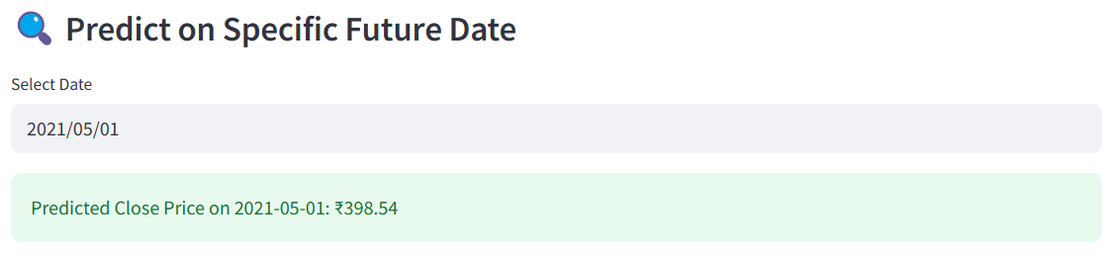

Fig.6 Future stock price prediction by taking input from user

Results and Discussion

Evaluation Matrics
To assess the predictive performance of the machine learning models used in this study, several standard evaluation metrics were employed. These include:
- Mean Absolute Error (MAE): Measures the average magnitude of the errors between predicted and actual values, giving an idea of how far off predictions are on average.
- Mean Squared Error (MSE): Emphasizes larger errors by squaring the differences between predicted and actual values, which is useful for penalizing larger mistakes.
- Root Mean Squared Error (RMSE): Provides error magnitude in the same units as the target variable and is easier to interpret in financial contexts.
- R-squared (R²): Indicates the proportion of variance in the target variable that is explained by the model. A higher R² suggests a better fit of the model to the data.
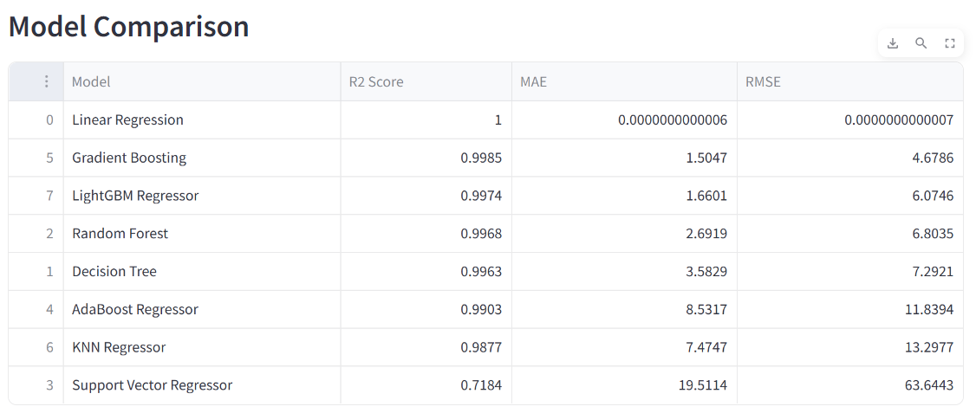

Fig.7 Comparison of all the models

Each model was trained on a historical dataset and evaluated on a separate holdout test set to ensure unbiased performance estimation. The calculated metrics offered quantitative insights into the effectiveness of each model in capturing trends, seasonality, and price movements of the stock data. These metrics were also visualized for comparative analysis, helping to highlight the stability and generalization ability of the models when applied to unseen data.

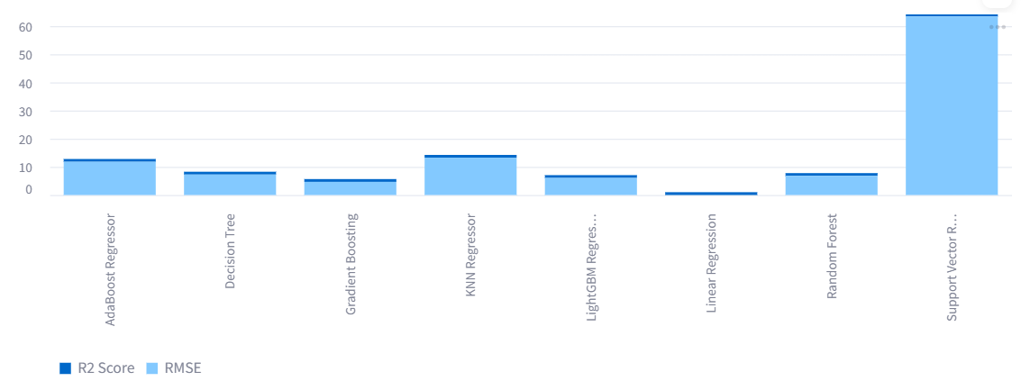

Fig.8 Graphical comparison of the models

Forecasts
The forecasting models achieved stable and reliable results when predicting stock prices for a short-term horizon of up to 15 days. By leveraging lag-based features such as previous days’ Open, Close, and percentage change values, the models were able to capture temporal dependencies and generate forecasts that followed logical market trends.
The predicted Close and Open prices displayed coherent directional movement in alignment with recent historical patterns. This indicates that the models successfully learned from past fluctuations and translated them into meaningful future estimates. The visual representation of forecasted values in candlestick format further confirmed the preservation of daily price ranges and realistic volatility.
Overall, the approach proved effective for short-term forecasting, maintaining accuracy across different forecast windows while delivering interpretable results that reflect actual market behaviour.
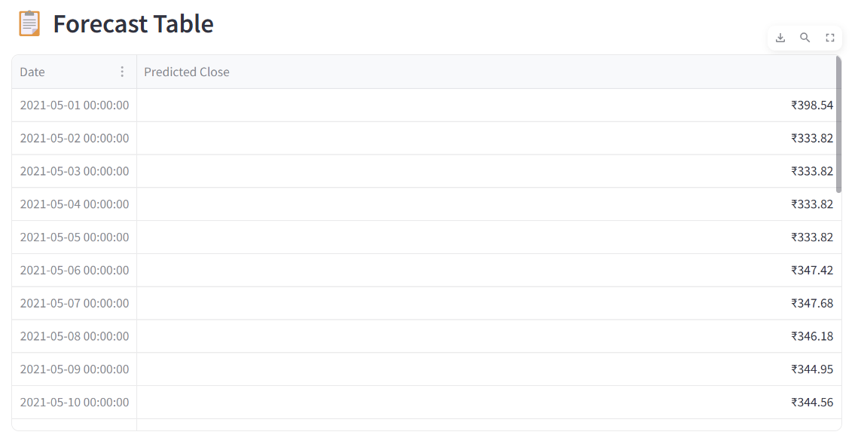

Fig.9 Forecast values for SVR Model

Best Performing Model
Among all the machine learning models implemented and evaluated, the Support Vector Regressor (SVR) emerged as the most effective for predicting stock prices in this study. Its ability to handle non-linear relationships in the data allowed it to accurately capture subtle patterns and short-term fluctuations. The SVR model consistently achieved lower RMSE and MAE values compared to other models, while maintaining a high R² score across the testing and forecasting periods.
SVR also demonstrated robust performance when applied to forecasting both Open and Close prices, particularly over short- and mid-term intervals (up to 15 days). Its generalization capability and resistance to overfitting made it well-suited for the volatility typically seen in financial time series data. These results suggest that SVR is a reliable and stable option for stock price prediction in practical applications.
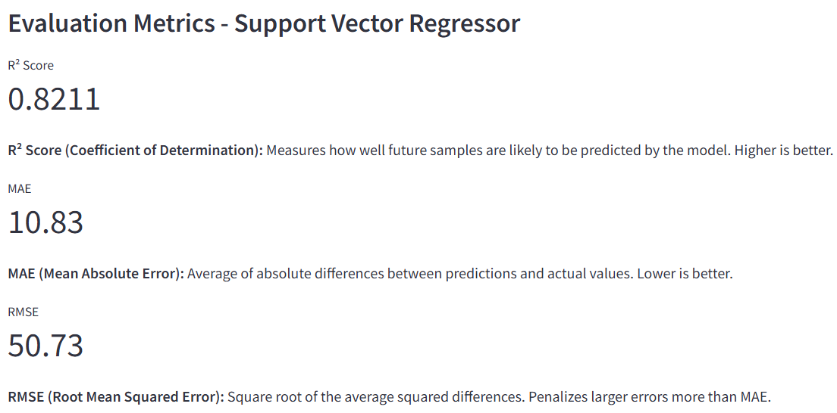

Fig.10 R², MAE and RMSE value of SVR

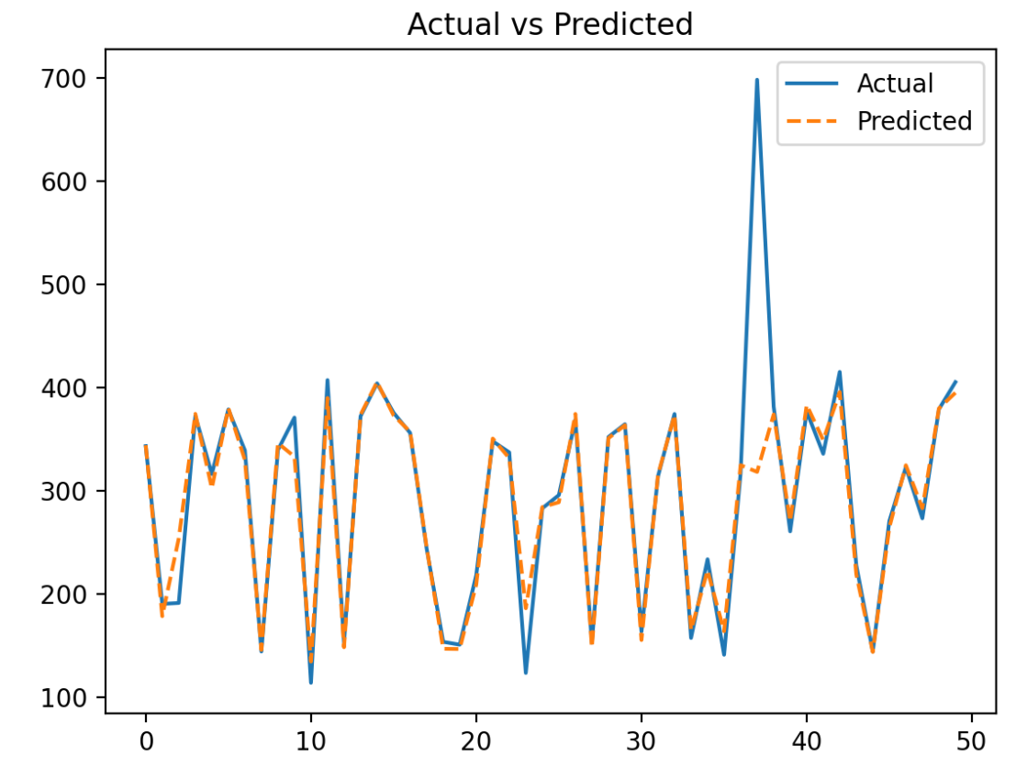

Fig.11 Graphical representation bethween Actual and Predicted values of SVR model

Conclusion

This study presents a robust, practical, and interactive system for stock price forecasting using explainable machine learning models. By leveraging lag features and incorporating technical indicators such as Moving Averages and Standard Deviations, the system provides a comprehensive and reliable framework for predicting stock prices. These features contribute significantly to the model's performance, capturing both long-term trends and short-term fluctuations in the stock market.
The interactive dashboard built with Streamlit allows for real-time analysis and visualization of stock data, enabling users to select different forecasting models, evaluate performance, and visualize predictions using time series and candlestick charts. The inclusion of model evaluation metrics such as RMSE, MAE, and R² ensures transparency and interpretability, providing users with insights into the accuracy and reliability of each model.
Moreover, the system is highly flexible and can be extended to other stocks with minimal configuration. By simply updating the input dataset and adjusting model parameters, this pipeline can be adapted for different financial assets, making it a versatile tool for stock market prediction. The ability to forecast both Open and Close prices with dual-model forecasting adds further value to the system, making it suitable for various trading strategies.
Overall, this project highlights the potential of machine learning in financial forecasting, offering a tool that can assist traders, analysts, and financial institutions in making informed, data-driven decisions. Future work could include integrating more advanced models, incorporating real-time data, and exploring additional features like sentiment analysis to improve the forecasting accuracy and scope of the system.

Future works

While the current stock price forecasting system offers strong performance, there are several avenues for improvement and enhancement to further increase its accuracy and applicability in real-world trading scenarios:
- Integration of LSTM and Hybrid Models: Long Short-Term Memory (LSTM) networks, a type of Recurrent Neural Network (RNN), are well-suited for time-series forecasting due to their ability to capture long-term dependencies in data. Integrating LSTM into the existing system can improve predictions by better modeling the temporal relationships within stock price movements. Additionally, combining LSTM with other machine learning techniques (e.g., Random Forest or XGBoost) to form hybrid models could further enhance forecast accuracy by leveraging the strengths of different algorithms. These hybrid models can better capture both short-term volatility and long-term trends.
- Incorporation of Real-Time News Sentiment Analysis: Stock prices are influenced by news events, market sentiment, and social media trends. By integrating a real-time news sentiment analysis component, the system can incorporate external factors affecting the stock market. This can be done by using natural language processing (NLP) techniques to analyze news headlines and articles, extracting sentiment scores that can be factored into the forecasting models. Incorporating sentiment analysis would provide a more holistic view of the market, improving the system's ability to predict market movements.
- Real-Time Forecasting and Integration with Trading Platforms: The system could be further extended to support real-time stock price forecasting, where users can receive minute-by-minute or hour-by-hour updates for more timely predictions. Moreover, integrating the forecasting system with popular trading platforms like Robinhood or E*TRADE could enable automated trading strategies based on the model's predictions, offering potential for algorithmic trading.
By pursuing these enhancements, the stock forecasting system can evolve into a more robust, adaptable, and insightful tool, offering even greater value to users in the dynamic and ever-changing financial markets.

REFERENCES
[1] H. Singh and M. Malhotra,
"A Time Series Analysis-Based Stock Price Prediction Framework Using Artificial Intelligence,"
International Journal of Scientific Research in Computer Science, Engineering and Information Technology, vol. 7, no. 1, pp. 123–130, Jan. 2021. [Online]. Available: https://www.researchgate.net/publication/376958007

[2] F. Moodi, A. Jahangard-Rafsanjani, and S. Zarifzadeh,
"Feature Selection and Regression Methods for Stock Price Prediction Using Technical Indicators,"
arXiv preprint arXiv:2310.09903, Oct. 2023. [Online]. Available: https://arxiv.org/abs/2310.09903

[3]T.A.Narayan,
"Stock Price Prediction in Indian Markets with a Case Study Analysis of Adani Group of Companies – ACC Limited,"
Journal of Philanthropy and Marketing, vol. 1, no. 2, pp. 88–95, 2025. [Online]. Available: https://journalofphilanthrophyandmarketing.org/index.php/JPM/article/view/101

